**2. Configuring a Servlet with Eclipse**

* Open Eclipse
* Go to the **File** menu. Choose **New->Dynamic Web Project**

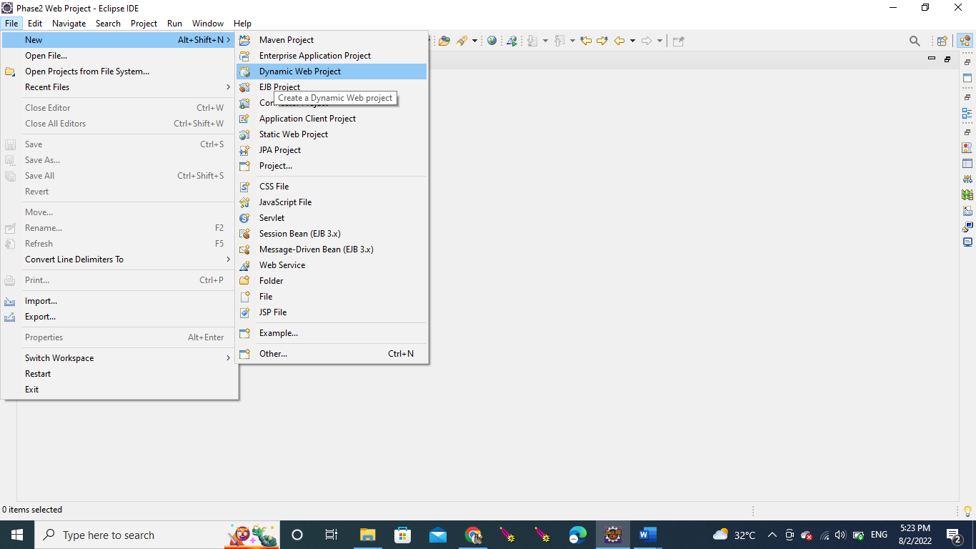

* Enter the project name as **FirstServlet**. Click on **Next**

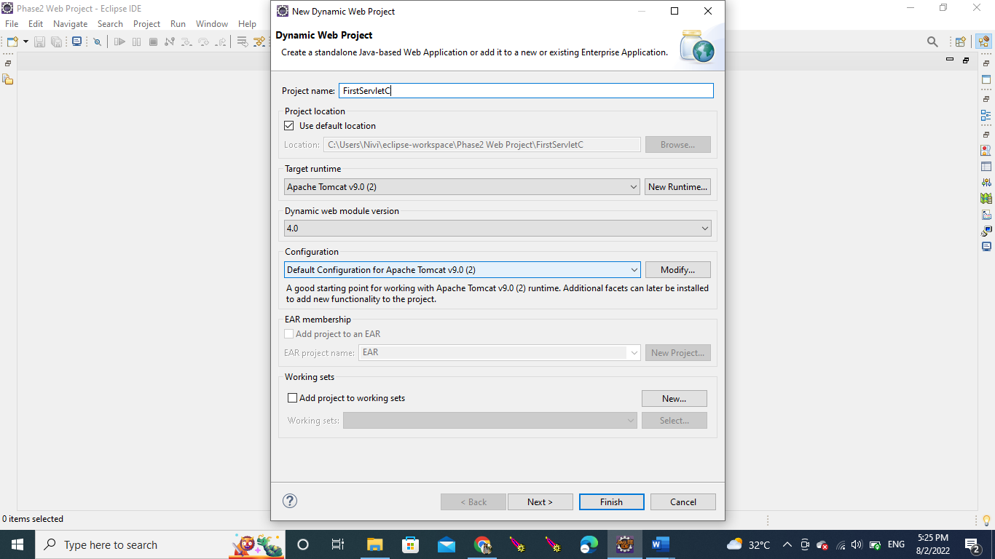

* Enter nothing in this screen and click on **Next**

* Check the checkbox **Generate web.xml deployment descriptor** and click on **Finish**

* In the Project Explorer, expand **ServletConcept->Java Resources**
* Right click on **src** and choose **New->Servlet**

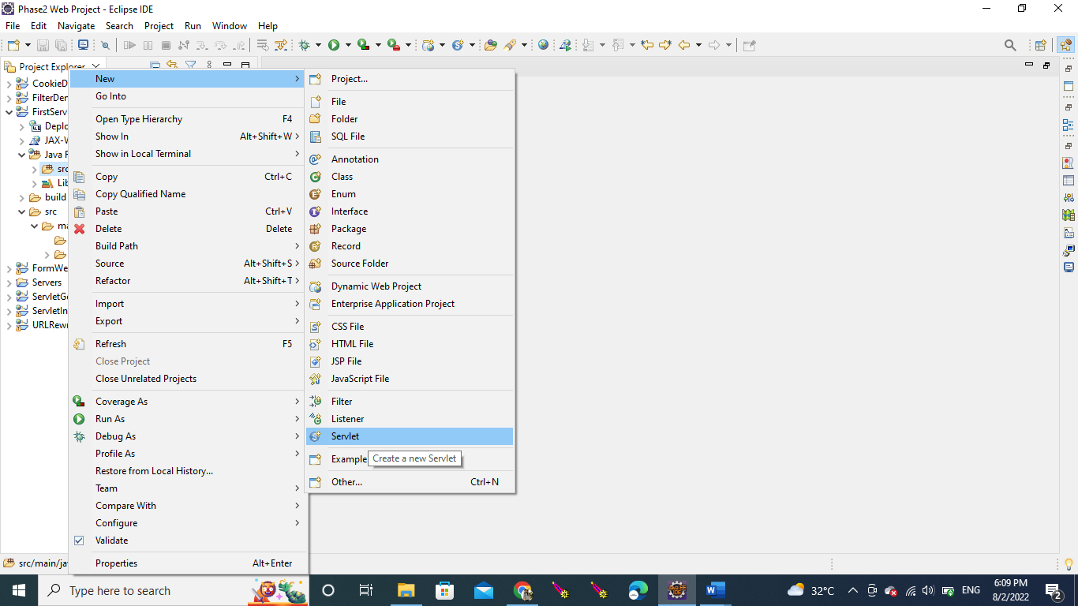

* In **Class Name,** enter **FirstServlet** and click on **Finish**

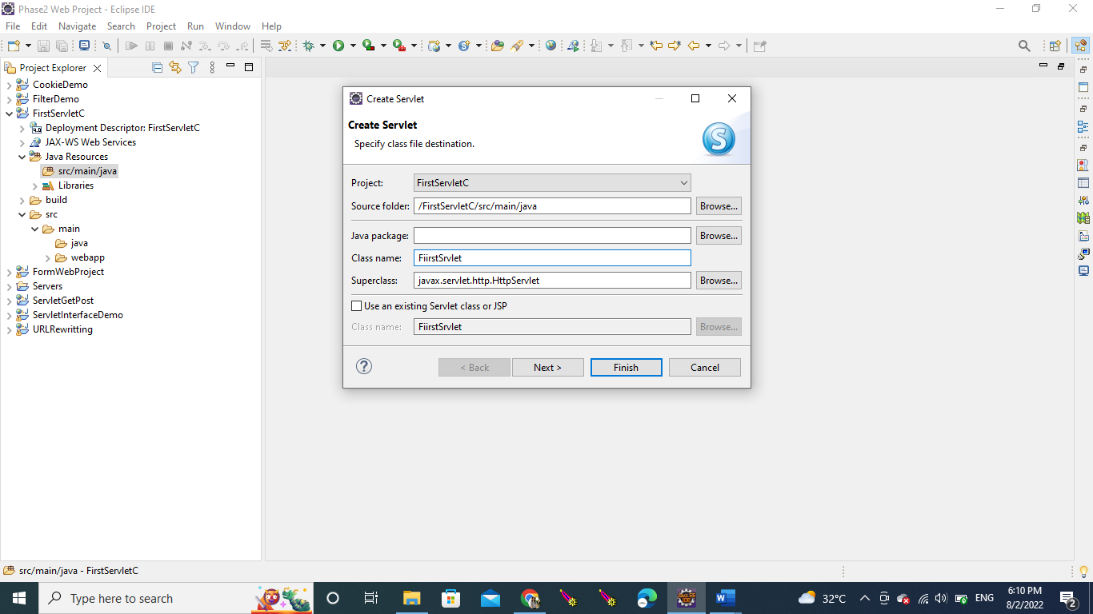

**FirstServlet.java File**

